Software Requirements Specification

For

Student Portal & Forum System

**Prepared By:**

**G**ROUP ‘F’

**Organization:**

Govt. Poly. Dhule

**Date created:** 12/1/2018

**Created By:**

1. Aarti S. Sharma (333)
2. Priyanka N. Akhade (301)
3. Shweta V. Pawar (334)
4. Pratiksha S. Sarode (320)

**Introduction**

* 1. Purpose

A student portal project that acts as an online portal between students and teacher. The student portal is a web portal where all information and all services that students need can be found in one place. Students now can interact with their administrator and mates both at the same time. It might be one of the best ways for the use of the technology for the benefit of student.

* 1. Product scope

Our project touches all the related boundaries of Online Student Portal. Two types of users are identified in this project student & administrator. A student can add or modify self details, can check time tables, participate in competitions, communicate with other members either through live chat or private messages, download related stuff, upload pictures and videos, view latest happening and results. Whereas an administrator can login, design, events, upload/download files, videos and pictures, design online quizzes and communicate either through live chat or private messages. It will helps the students to view college notices and information easily.

**Overall Description**

2.1 Product Perspective

Following are the main features that include in our project portal:

* Cross platform support: Offers operating support for most of the known and the commercial operating system.
* User Account: The system allows the user to create their account in the system and provide features of updating and viewing profiles.
* Search: Search is simple local search engine based on keywords.
* Discussion forum: Provides user with platform to discuss and help each other with their problems.

2.2 Product Functions

* This software will able to show the current uploaded notices declared by college.
* The news feed of the portal contains maximum 10 notices.
* It will easy for student as the notice-boards are not easily seen.
* It provides another tabs for various branches.

2.3 Operating Environment

This is a web based system and hence will require the operating environment for client and server GUI.

2.4 Design and Implementation Constraints

This system is provisioned to be built on the Django framework which is highly flexible. Decision regarding which database to use should be taken considering the fact that data being exchanged or stored is large, and the appropriate data management system will yield efficient performance.

2.5 User Documentation

User Documentation includes functional description of the project that is portal system. It includes introductory manual or reference manual for user. It is easy to use the documentation.

2.6 Use case Diagrams

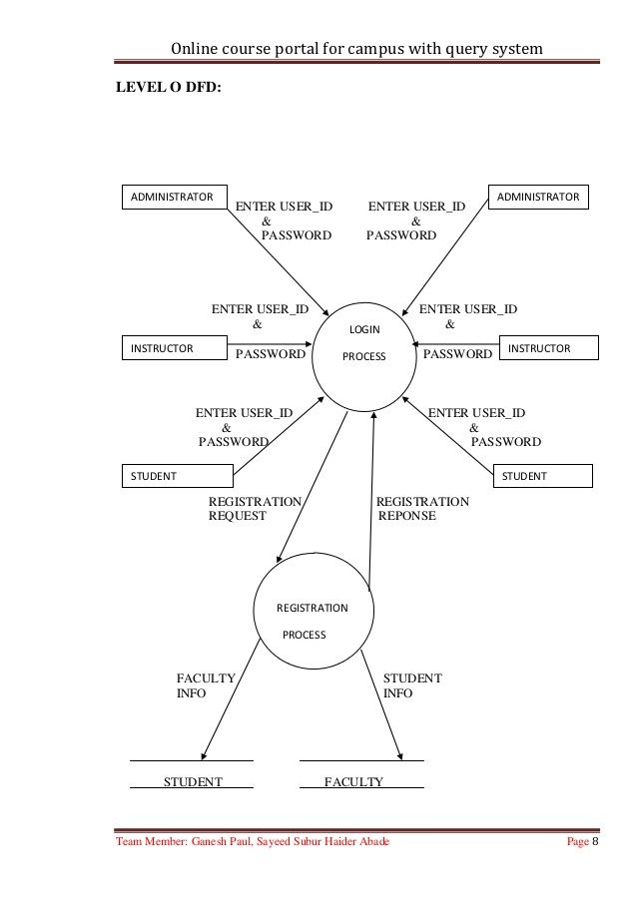

3.1 External Interface Requirements

* + User Interfaces
* All pages of the system are following a constraints theme and clear structure. The occurrence of errors should be minimized through the use of check boxes, radio buttons and scroll down in order to reduce amount of text input of user.
* JavaScript implements in HTML in order to provided Data Check before submission
* HTML tables to display information to give a clear structure that easy to understand by user.
* Error message should be located beside the error input which clearly highlight and tell user how to solve it.
* If the system error, it should be provide the contact methods. The page should display the project process in different color to clearly reflect the various status that’s student done.
* The system should be provide feedback from for all user to give a comments or asking questions. It should provide a FAQ to minimize the work load of system administrator.

3.2 Hardware Interfaces

* Service Side

The web application will be hosted on of the department’s Linux servers and the connecting one of the schools Oracle Database server. The web server listening on the web standard port. The web standard port is port 80.

* Client Side

The system is a web application; Clients are requiring using a modern web browser such as a Mozilla Firebox 1.5, Internet explorer 6 and Enable Cookies. The computer must have Internet connections in order to able to access the system.

3.3 Software Interfaces

* Server Side

The UOP already has the required software to host a Java web application. An Apache web server will accept all request from the client and foreword SUMS specific required to Tomcat 5.5 server container with J 2 EE 5.0 and strut 1.2.8 hosting SUMS. The development database will be hosted locally (using MySQL); The production database is hosted (using Oracle).

* Client Side

In an OS is capable of running a modern web browser with support HTML Version 3.2.

3.4 Communications Interfaces

The HTTP Protocol will be used facilitated communication between client and server.

**System Features**

Reliability:

The system has to be very reliable due to importance of data and the damages incorrect or incomplete data can do.

Availability:

The system is available 100% for the user and is used 24hrs a day and 365 days a year. The system shall be operational 24 hours a day and 7 days a week.

Accuracy:

The accuracy of the system is limited by the accuracy of the speed at which the employees of the library and users of the library use the system.

**Other Non-functional Requirements**

5.1 Performance Requirements

This software will able to handle following tasks:

* At least 10 news-feeds notices can be seen at a time.

* The previous notices are stored in database.

* The student corner is provide separately.

5.2 Safety Requirements

This software will ease the process of student grading. At the end of every semester each student will receive a grade sheet generated by administration using the data uploaded by course instructor on this s/w. All important details should be maintained in hard copy as well.

5.3 Security Requirements

This software will,

Authenticate each user, who logs in.

Students can’t able to publish notices.

To publish notices, administrative password is required.



5.4 Software Quality Attributes

**Conceptual Integrity:**

Conceptual Integrity defines the constancy and coherence of the overall design. This includes the way that components are design as well as factor such as coding style and variable naming.

**Maintainability:**

Maintainability is a ability of the system to undergo changes with degree of ease. This changes could impact components services features and interface when adding or changing the functionality, fixing error and meeting new business requirements.

**Reusability:**

Reusability defines the capability for components and sub system to be suitable for in other application. Reusability minimize the duplication of components and also implementation time.